**Discord Pilot D R A F T v 0.9 – general structure and guidelines**

# (Tool prep:) 1. Basic Instructions

**IN GENERAL**:

file volume limit 8 MB

comments/message limit 200 to 250 words / ~ 2000 characters  
 comments in English language  
 commentators review the entire contribution or contribute something to the content

commentators paste only factual comments

**FOR AUTHORS**

1. The upload follows an AIW workshop presentation. Only contributions to the corresponding AIW  
 are allowed.

3. Papers need to be complete in a sense of a scientific contribution (references, literature,   
 if necessary footnotes).

4. Papers on every page need to be marked as  *< This is work in progress. Please do not cite or distribute without permission from the author.  
 Copyright ©first name/name >* 5. Papers need to be of file type "PDF" 6. Movies or other animated contributions may only be inserted as a link!!!

**BEST PRACTICES**

1. Click on „XX. American Indian Workshop papers“

2. Open a Thread using the plus in the comment line **+**

3. Title the thread with your name <first name; name>

4. Upload a paper within the thread using the plus in the comment line **+** 5. Title your contribution with <AIW; panel; full paper title>

5. Enter „start discussion“ in the comment line

# 2. Conduct Guidelines

# - The discussions take place in an academic environment, the argumentation is factual.

# - Openness, tolerance and respect for differing opinions are expected.

# - Personal attacks on persons inside or outside the discussion groups are not permitted.

# - Expressions of opinion must be comprehensible; their constituent elements can be substantiated in the discourse if necessary.

# - In case of non-compliance with the above rules, comments or registered participants may be excluded.

# 3. General Timeframe

**AUTHORS/ COMMENTATORS**the period for the whole process is about 5 months after the end of the respective AIW

1. The upload period starts 2 weeks after the corresponding AIW
2. The commenting period is 8 weeks
3. The revision period is 8 weeks

(After the end of the revision period the documents will be archived)

# 3. Tests in prep for the Pilot 43rd AIW

|  |  |  |
| --- | --- | --- |
| **Activity** | **Topic** | **Result** |
| 1. Uploads |  |  |
| 1.1 file types | -PDF (preferred!!!) | ok |
|  | -Word | ok |
|  | -Excel | ok |
|  | -Powerpoint | ok |
|  |  |  |
| 1.2. posted links | -youtube files or comparable formats | ok |
|  | -documents | ok |
|  | -URLs | ok |
|  |  |  |
| 1. Comments | -2000 characters, ~ 220 words | ok |
|  |  |  |
| 1. Emailing | -email list AIW server  -select and address email list AIW server | ok* |
| * 1. Define email lists for | -Editorial Board  -AIW Authors  -AIW Commentators  -Admins | ok** |
| 1. not authorized deletion | -deletion of one another’s document/link not  allowed for users (exception admins)  -deletion of one another’s comment not  allowed for users (exception admins) | ok  ok |
|  |  |  |
| 1. roles and legitimations | **Admins** (1 person plus proxy) (admin and transactions) -manage roles and legitimations, -address email lists and grant legitimations -upload contributions, -delete contributions, -delete comments  -finalize and archive (archive AIW Server?) | ok |
|  | **Editorial Board** (proposal: WS organizerplus proxyand 1 committee person plus proxy) -instructs Admins to delete contributions/   comments (emails/Discord message) in case  of troubles  -can timeout members in case of troubles -instructs Admins to archive contributions  (emails/Discord message)  -invite for upload contributions (email list)  -invite to comment contributions (email list)  -close discussion period (email list)  -uploads/comments |  |
|  | **Authors**  -upload  -delete own contributions/comments  -comment | ok |

# * corresp. AIW-organizers will have to invite authors/ commenting AIW participants due to EU GDPR **email-lists in case of demand beyond authors/ commenting AIW addresses follow AIW standards

# v0.9 roles and legitimations in Discord (as is today)

|  |  |  |
| --- | --- | --- |
| **Role** | **Tasks for the Pilot testing** | **Who** |
| admin | admin | Sonja Ross (for the time being), et.al |
| authors | upload AIW contribution, start discussion, moderate discussion on the paper | corresponding AIW presenters |
| editorial board member | Formal checks: are papers eligible, is the framing academic, disclaimer on every page? | Carlo Krieger, Sonja Ross (for the time being), et.al. |
| committee member | follow the pilot | AIW committee members |
| @everyone (Discord standard-role) | -- | Corresponding AIW participants.  Authors may invite additional colleagues for comments even if they were not participants of the corresp. AIW |

|  |  |  |  |  |  |
| --- | --- | --- | --- | --- | --- |
| **Activity** | **Admin** | **Author** | **Editorial board member** | **Committee member** | **@everyone** |
| tbd |  |  |  |  |  |

# Preparation Test- Pilot based on 43rd AIW

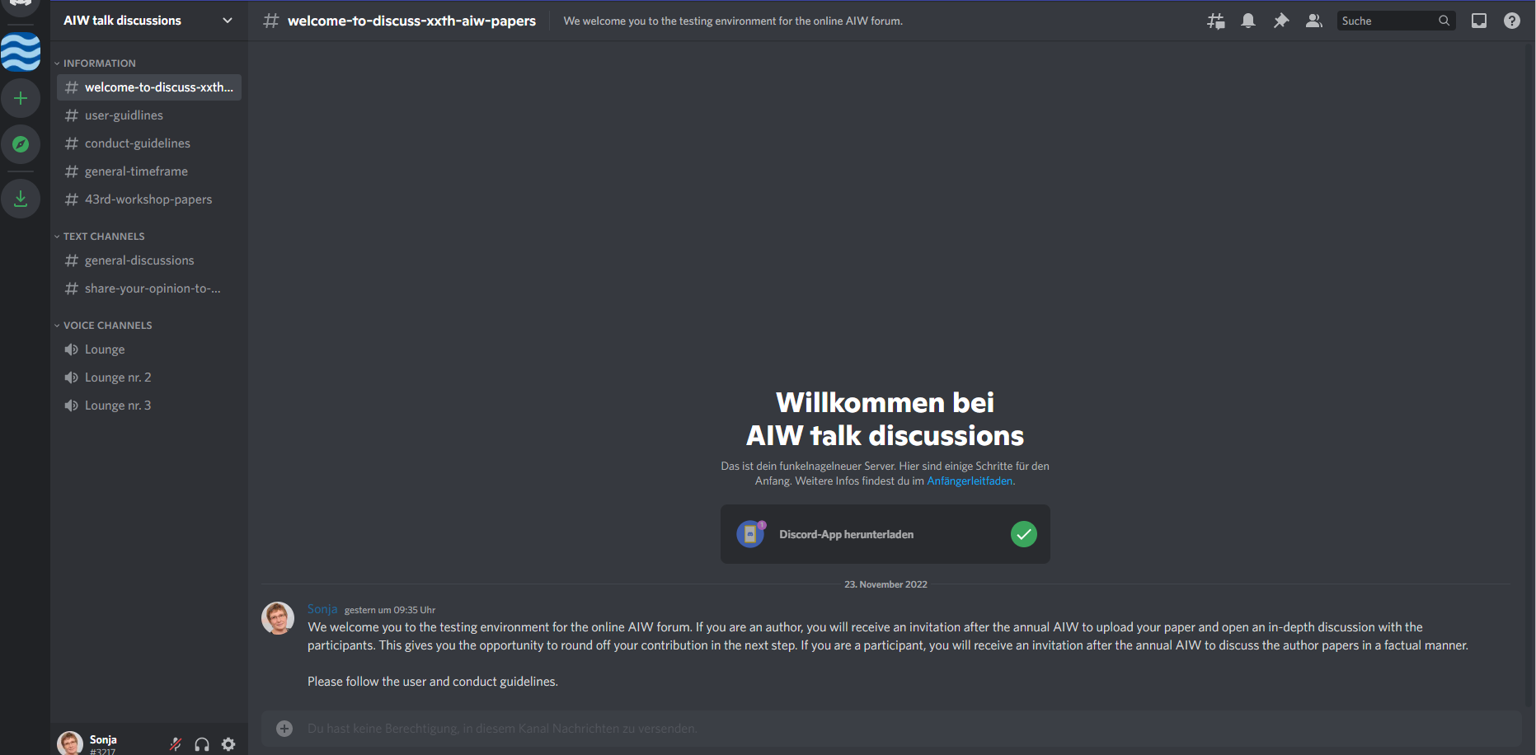

|  |  |  |
| --- | --- | --- |
| **Activity** | **Timeframe** | **Result** |
|  |  |  |
| contact Carlo Krieger, Tanja Giberyen | Oct, 2022 | ok |
| introduction/ planning | Nov, 2022 | ok |
| information/ invitation Committee Members | Nov, 2022 | ok |
| start information/ invitation authors | Dec, 2022 |  |
| start information/ invitation commentators  (43rd AIW participants) | Jan, 2023 |  |
| end of commentators period | End of Feb, 2023 |  |
| evaluation of opinions on the tool/ handling | March, 2023 |  |